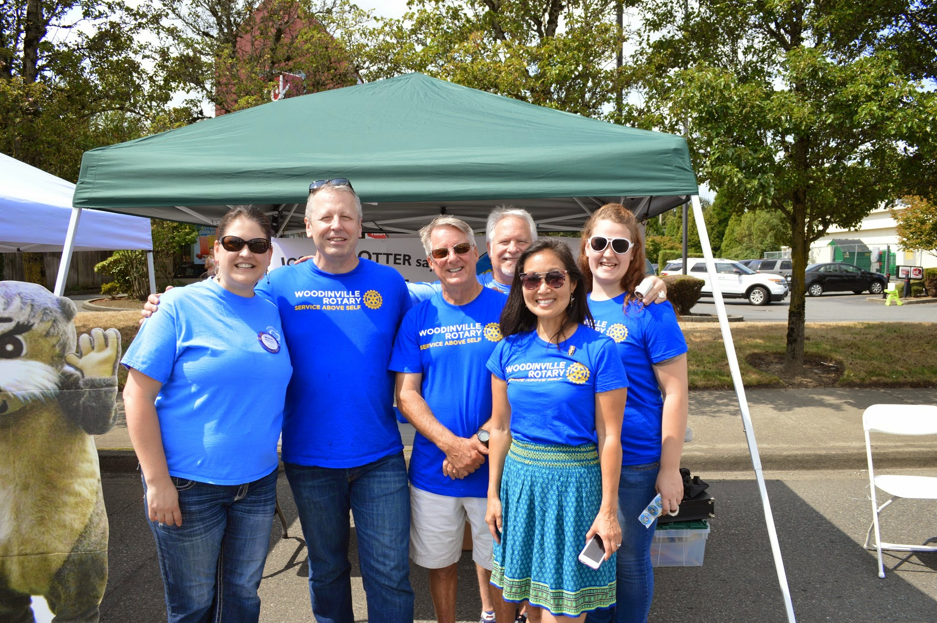 | 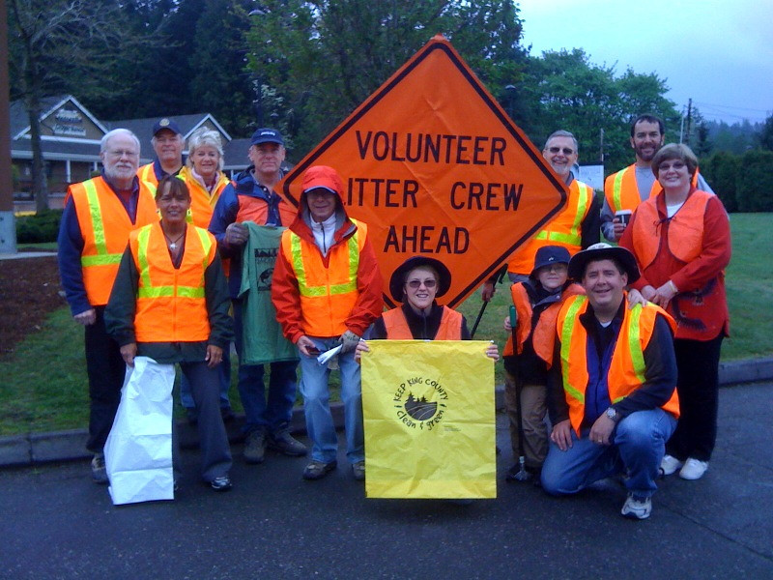
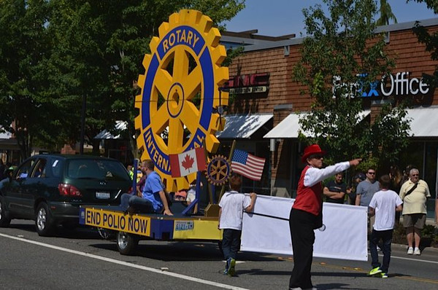 | 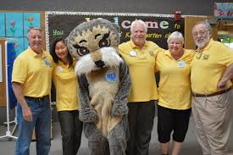

This is
Rotary…

service above self…  Rotary is a service organization of business and professional men and women united worldwide, who provide humanitarian service, encourage high ethical standards in all vocations, and work toward world understanding and peace. Belonging to a Rotary  Club gives men and women an organized outlet for contributing to their community.  Our differing occupations, cultures, and countries give us a unique perspective. Our shared passion for service helps us accomplish the remarkable.  What makes us different?  Our distinct point of view and approach gives us unique advantages:  - We see differently: Our multidisciplinary perspective helps us see challenges in unique ways.  - We think differently: We apply leadership and expertise to social issues—and find unique solutions.  - We act responsibly: Our passion and perseverance create lasting change.  - We make a difference at home and around the world: Our members can be found in your community and across the globe.  Rotary members meet weekly to build friendships and plan service activities. Rotary clubs are autonomous and determine their own service projects based on local needs and the interests and abilities of members.  Rotary clubs are non-religious, non-governmental and open to every race, culture and creed. Club membership represents a cross-section of local business and professional leaders who share the common goal of service to others. | 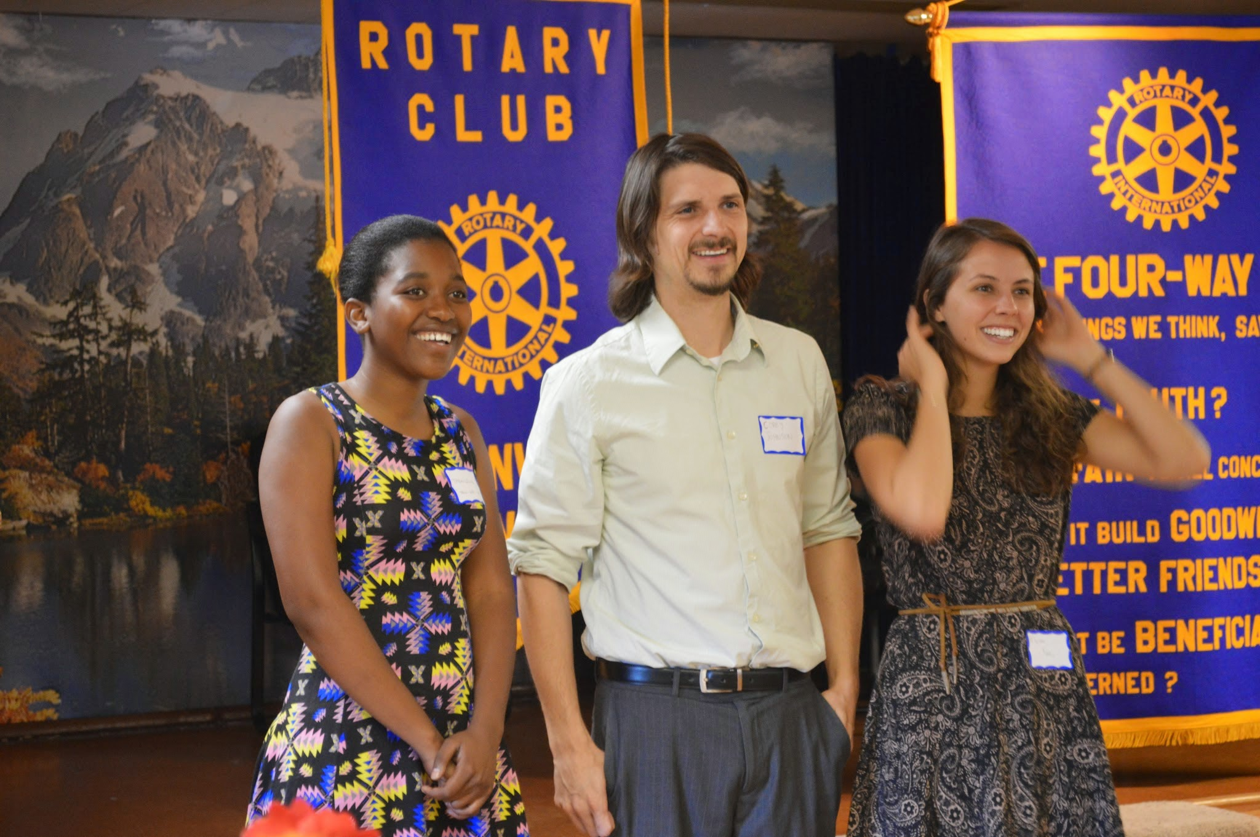  Paul P. Harris and fellow business leaders who believed in the ideal of “Service Above Self ” formed the world’s first service club in 1905.  Today, Rotary has a global network of 1.2 million members in more than 33,000 clubs in over 200 countries who come together to create positive, lasting change in our communities and around the world.  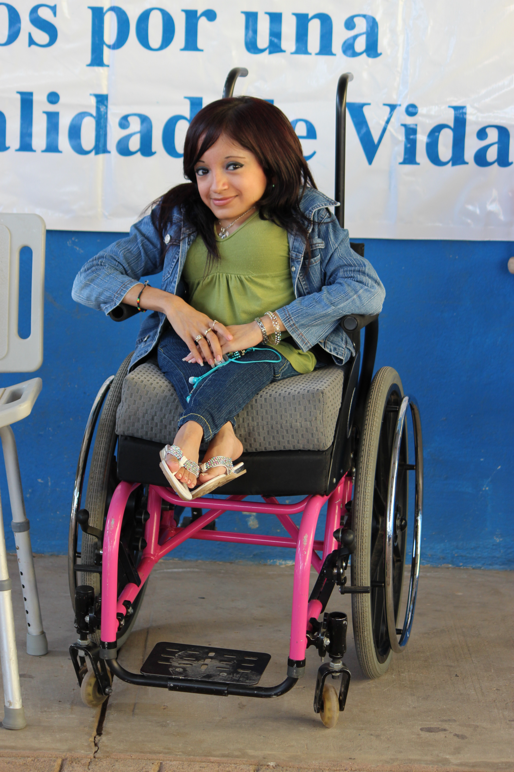
serious business and having fun…  In 1986, a group of Woodinville business people and community leaders who subscribed to the ideals of “Service Above Self” and “Having Fun Is Serious Business” founded the Rotary Club of Woodinville. Today, the club has over 50 members committed to service and has provided nearly 2.5 million dollars for community projects at the local, national, and international level.  The Rotary Club of Woodinville is known for its congeniality, its uniqueness among Rotary clubs and, above all, the good-natured companionship our gatherings instill in all our members. We are stewards of our community. We:  - Share resources with others in need  - Provide fellowship with others  - A network of professional who make connections  Belonging to the Rotary Club of Woodinville gives men  and women an enjoyable and organized way to make  a contribution to our local community and the world.  By using our skills and expertise globally, members  also enhance their professional network, career  development, and cross-cultural understanding.  Members learn about a variety of subjects through the speakers at weekly meetings. Each meeting includes a  guest speaker, ranging from top business leaders to government officials to members of the arts to local and national charitable organizations. We make a concerted effort to hear people from all walks of life so we can learn more about our community and this region, its problems and opportunities.  You are welcome to “make-up” missed meetings while traveling by visiting at a regular meeting of another club. You are always welcome at any club. | 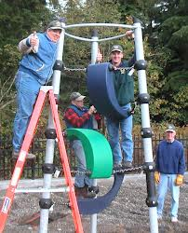  The essence of Rotary is summed up in the “Four-Way Test” of the things we think, say or do:  - Is it the TRUTH?  - Is it FAIR to all concerned?  - Will it build GOODWILL and BETTER FRIENDSHIPS?  - Will it be BENEFICIAL to all concerned?

supporting the community…  We are community stewards. The Rotary Club of Woodinville has contributed nearly $2.5 million dollars and countless volunteer hours for community projects at the local, national and international level and to organizations in our community through our community grants program.  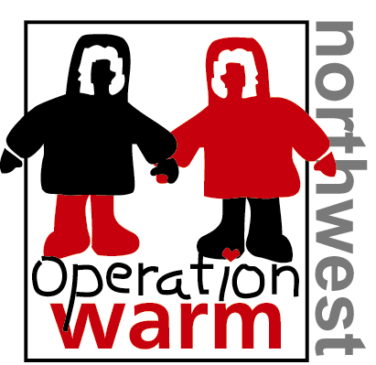  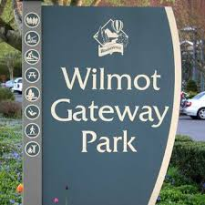 | Partial listing of community support:  - Literacy and Reading  - Scholarships and Education  - Operation Warm Coats  - Camperships  - Water Saftey with Josh the Otter  - Community Parks such as Wilmot Gateway, Rotary Community Park and Woodinville Little League Diamonds  - Rotary First Harvest and Food Banks  - Scouting  - Homelessness  - Domestic Violence  - Children’s County Homes  - Northshore Senior Center  - Hopelink  - Little Bit Riders  - Northshore Performing Arts

being involved in international projects…  Members of the Rotary Club of Woodinville participate in a broad range of humanitarian, intercultural and educational activities designed to improve the human condition. Rotary’s humanitarian grants support projects that provide health care and medical supplies, clean water, food, job training, youth development, and education to millions of people in need, particularly in the developing world.  Rotary’s flagship project is polio eradication. For decades we have supported the End Polio Now partnership.  Rotary also provides numerous grants each year to fund the work of Rotary volunteers, who travel to parts of the world where their technical expertise and knowledge are most needed to alleviate hardship and solve problems.  In addition, Rotary builds understanding through international scholarships, exchange programs  and humanitarian grants. The Rotary Centers for International Studies in peace and conflict resolution is an innovative program designed to educate tomorrow’s peacemakers. Hosted at seven leading universities around the globe, the program funds 60  Rotary World Peace Fellows forgraduation studies in international relations, conflicts studies and  negotiation.  Since 1947, some 35,000 students from 110 countries have studied abroad as Rotary Ambassadorial Scholars. Rotary’s Group Study Exchange has helped more than 45,000 young professionals explore their  career fields in other countries. And each year, some 9,000 secondary school students experience life in another country through Rotary Youth Exchange. | For over 25 years, Woodinville Rotary members have started and supported international projects such as:  - Mobile in Mexico  - Multiple Medical Missions  - Polio Eradication  - Water Manufacturing Plant and Water Filers  - Engineers Without Borders  - Computers  - Education and Literacy  - Earthquake Relief  - Youth Exchange

a commitment to service…  Membership in Woodinville Rotary involves a commitment to service, including:  - Regular attendance at weekly meetings.  - Active participation in at least one committee.  - Prompt payment of initiation fees and monthly dues.  - Commitment to major fundraising activities as established by the membership.  - Contribution to the Rotary International  Foundation  Membership costs include an initiation fee of $150. Monthly dues of $95, which includes “The Rotarian,” a monthly Rotary magazine, breakfast at meetings and a quarterly donation to the Paul Harris Foundation. Other contributions include two auction tickets for the major fundraiser, which costs $250, whether you attend or not.  Members are occasionally “fined” at meetings as a humorous way to recognize individual Rotarians for their achievements in the local and international community, and for contributions of service to the club. Members also offer “happy dollars” to note important life events.  Woodinville Rotary is committed to supporting the  Rotary Foundation projects by having 100% participation by its members in annual Foundation donations through a minimum $100 donation each year (part of monthly dues). Rotarians become Sustaining Members of the Foundation with an annual minimum gift of $100. When the cumulative amount reaches $1,000, the Rotarian is recognized as a Paul Harris Fellow. | To learn more about the Rotary Club of  Woodinville, visit:  http://www.woodinvillerotary.org  or contact us:  Club Administrator  Rotary Club of Woodinville  P.O. Box 2016  Woodinville, WA 98072  Phone: 425-405-5089  Email: club@woodinvillerotary.org  The Rotary Club of Woodinville meets weekly from 7:00 to 8:30 AM at:  Sammamish Valley Grange  14654 148th Avenue NE  Woodinville, WA 98072  “The day you join the Greater Woodinville Rotary Club, it becomes a new club, for your personality, ideas and participation give our club a new character, a new collective personality.”

getting important things done…

If It Weren’t For The Rotary Club of Woodinville ...

1. Little Leaguers could still be looking for a place to play.
2. Wilmot Gateway Park would be missing many features.
3. Maltby Food Bank would still be looking for a home.
4. A thousand kids will face winter without a new, warm coat.
5. Rotary Community Park would be just a draftsman’s vision.

6. Without summer reading programs, kids fall behind more.

7. Mobile Mexico won’t serve over 300 mobility-challenged individuals.

8. Northshore Scholarship Foundation wouldn’t surpass year 30.

9. No music in halls of the Secondary Academy for Success.

10. Two fewer buses at the Northshore Senior Center.

11. Dreams of college and career would be just that—a dream.

12. Josh the Otter might not have found Puget Sound.

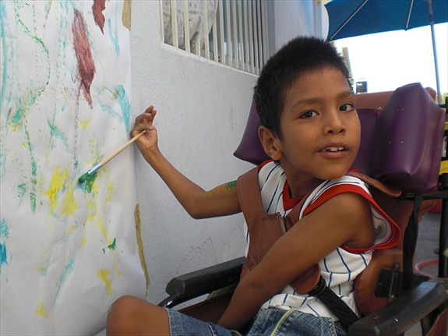 | 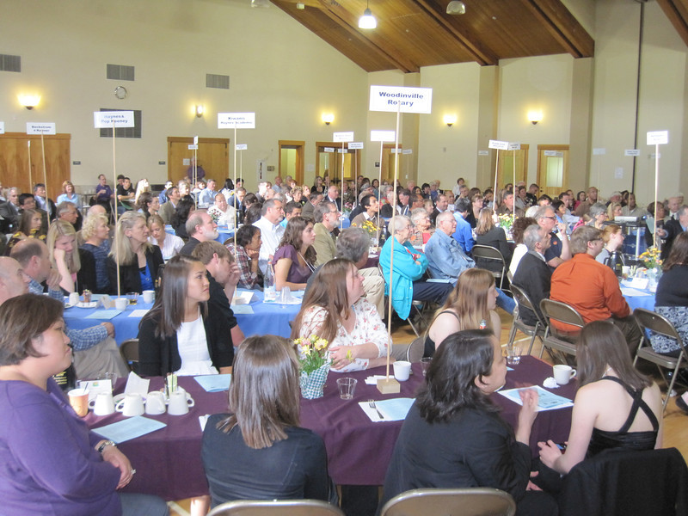

Join Us For A Meeting

Every Tuesday from 7:00 to 8:30 AM
Sammamish Valley Grange
14654 148th Avenue NE
Woodinville, WA 98072

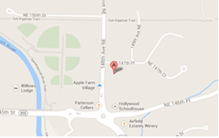

Contact Us

Rotary Club of Woodinville
P.O. Box 2016
Woodinville, WA 98072

Phone: 425-405-5089

Email: club@woodinvillerotary.org

This is
Rotary…

